**Bugs/suggestions EMLO visualizations Shiny App**

**All graphs**

1. The green control buttons for scrolling, zooming in/out and centralizing the graph do not work properly. Sometimes they do not work at all (mostly after you first used one of the other control buttons) or they do not stop doing what they should do (e.g., the zoom-out button zooms out until the graph is one small dot).
2. Sometimes other strange things happen, such as this after returning from the tab with the other visualization:

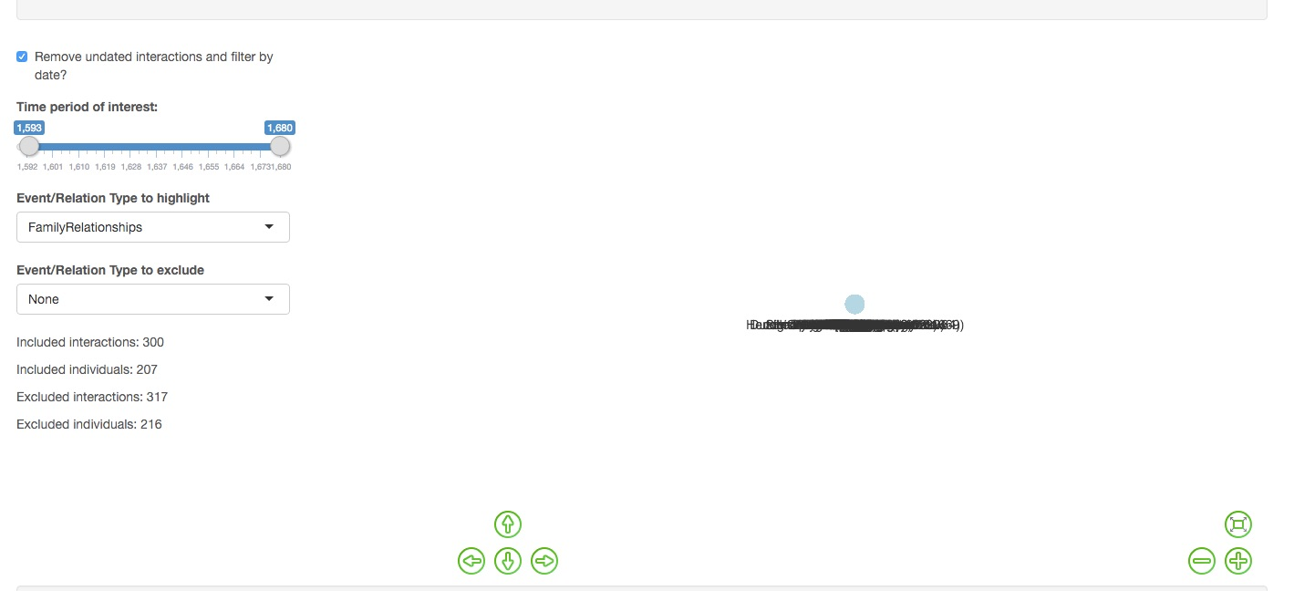

1. The graph occupies only a small part of the screen, which makes it difficult to navigate in. Would there be a way to have the graph occupy a larger part of the screen? (Perhaps by having the explaining text and the controls partly hidden and having them appear when hovering over that part?)
2. The comma should be removed from the years in the date scroll bar.
3. The default setting should include all undated events.
4. I would like the nodes representing organizations to have a different colour from the nodes representing people, e.g., green.
5. The default setting for highlighting event/relation types should be ‘None’.
6. The visualizations do not include events that involve a date range (‘Duration’ or ‘In between’) when not the whole date range is selected. E.g., when someone studied from 1639 to 1643 and you select the years 1640-1650 it does not appear nor when you only select 1641. I think it should show in both cases, since that event partly took place in the year(s) selected.
7. When an event took place, e.g., before 1635, the visualization does not include this event when you select the year 1634, but only when you select 1635. Apart from the fact that before 1634 strictly spoken means 1634 or earlier, which does not include 1635 (but I would like to include it because it has often been used inclusive when inputting data), it should include all years before that year.
8. What was the idea behind using the primary categories (‘Event category’) for the include function, while using subcategories (‘Event type / relationship type’) for the exclude function? I would rather only use the primary categories, BUT if possible also include the subcategory (of BasicData) FamilyRelationships.
9. The invisible boundary between the graph and the controls makes it a bit difficult to navigate, sometimes making you scroll in the graph when you want to scroll in the rest of the page or vice versa.
10. The person/organization and location names seem to be linked to the EMLO database. This should prevent name variants to be identified as different people/organizations and locations. Is this correct?
11. You expect than when clicking on a node you see all events involving the selected individual, but there is something strange going on. E.g., Arnold, Nicholas is included as secondary participant in other spreadsheets, but when you click on him in the graph, the table only shows the events from his own spreadsheet in which he is primary participant. On the other hand, when you click on Frederick V you see his connections, being secondary participant, with different primary participants from multiple spreadsheets. What is going on here?
12. Likewise, Hotton, Goddofred; Haak, Theodor; and Spanheim, Friedrich are all connected (through family relationships), but clicking on Spanheim only produces a table with him being the secondary participant in an educational relationship with Arnold, Nicholas.

**visNetwork - Whole Network**

1. I would like a search/selection function for people/organizations (which also makes a table with all events involving the selected individual appear). This will be absolutely necessary when we use the data from all spreadsheets. What happened with the ‘Highlight node’ function from the screenshot in GitHub? I like it! See:

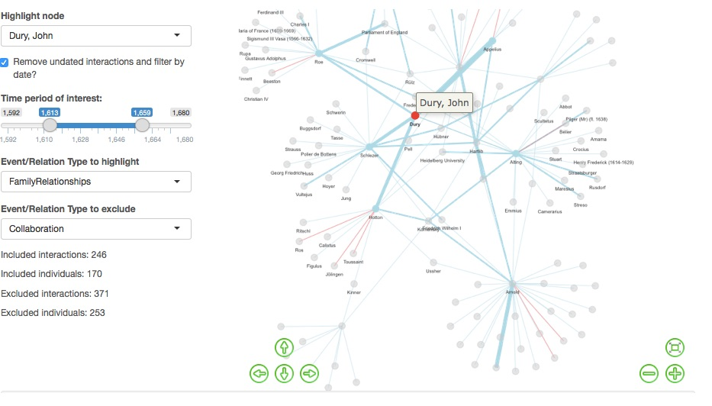

1. When I select FamilyRelationship to be excluded some people are disconnected from the network but their nodes remain (e.g., Schlezer, Johann Sr. (d. 1599), grandfather of Johann Friedrich Schlezer), while other nodes seem to disappear altogether (e.g., Couet du Vivier, Maria)?

**Table**

1. Please remove the dots from the headings.
2. When you click on the sort button in the ‘Secondary.Participant.Name’ column, the participants are not ordered alphabetically. Could you please arrange that?
3. When you click on the sort button in the ‘Event.or.Relationship.Type’ column, the types are not ordered alphabetically nor are they grouped together. What is the ordering principle? See, e.g., ‘Meeting’:

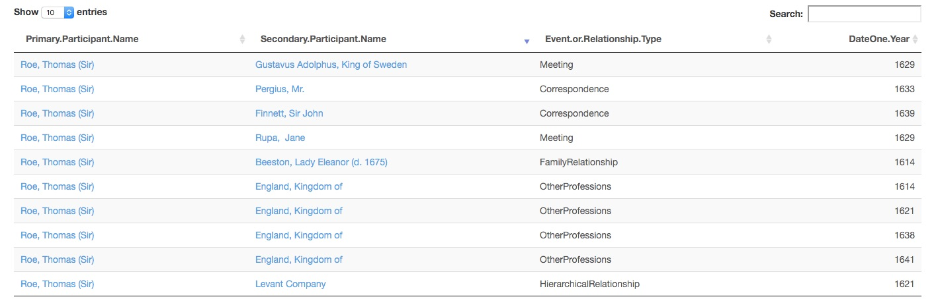

1. There should be other/more columns to choose from. The columns to choose from should be:

* Event category
* Event type / relationship type
* Event name / description
* Primary participant Name
* Role of primary participant
* Secondary participant Name
* Role of secondary participant
* Date one year
* Date one month
* Date one day
* Date one uncertainty
* Date two year
* Date two month
* Date two day
* Date two uncertainty
* Date type
* More details of place (free text)
* Type-ahead, or Place if new location
* Location name uncertainty
* Source
* Source details
* Additional notes

1. The preselected columns should be:

* Event category
* Event type / relationship type
* Primary participant Name
* Role of primary participant
* Secondary participant Name
* Role of secondary participant
* Date one year
* Date two year
* Date type
* Type-ahead, or Place if new location

1. How do you remove a selected column?
2. When you click on the name of a person or an organization (and probably also of a location, but the ‘Type-ahead, or Place if new location’ is lacking), you are redirected to EMLO within the same screen. Could you have it open in a new screen? The reason for this would be that when you return to the previous screen, all your selected choices are gone.
3. Please remove the Included/Excluded interactions statistics (but keep the Included/Excluded individuals statistics and rename it ‘Included people/organisations’ and ‘Excluded people/organisations’.

**Select Two Individuals graph**

1. The default setting for the three drop-down selection menus should be ‘None’.
2. When you toggle on/off the ‘Remove undated interactions and filter by date?’ check box, your selection of people is gone. Can you prevent this from happening?
3. Could you add a table with all events involving the selected individual here as well?

**Extra (if there is development time left or easy to make)**

1. Would it be possible to have the nodes change in size in proportion to the number of edges a node has?
2. Would it be possible to include a function in the drop-down selection menus in the ‘Select Two Individuals’ graph that allows you by typing a letter to leap to the first name beginning with that letter?
3. Would it be possible to show the (multiple) relationship type(s) between two people when hovering over the edge?